Documentation of Register Populations on DST Project 708237

Author: Rune Haubo B Christensen (RHBC, Rune.Haubo.Christensen@regionh.dk)
Date: 2022-10-13; last edit 2022-10-21.

Contents
Introduction - 1 -
Register sources on the Danish population on DST project 708237 - 1 -
Our population definition - 2 -
Comparison of registers and populations - 3 -
Characterization of POP - 5 -
Appendix - 6 -
Location of registers on DST project 708237 - 6 -
Links to more information on the registers - 7 -
Revision log - 7 -

Introduction
This document describes the registers on the DTS project 708237 representing the Danish population and the derivation of a population data set for use in statistical analyses. The registers are compared in terms of how many subjects they include over time from 1960 to 2021.

Register sources on the Danish population on DST project 708237
There are five register sources on the Danish population on DST project 708237 described in the following table also indicating the current availability on 708237:
Register | DST Label | Availability
CPR (t_person) | Det Centrale Person register | Until 2021-12-07
BEF | Befolkningen | Annually until 2019 (Dec. 31st)
BEFBOP | Befolkningens bopæl | Until 2020-10-29
VNDS | Historiske vandringer | Until 2021-12-31
DOD | Døde i Danmark | Until 2021-12-31
The location of the registers on 708237 and links to further information is provided in an appendix.
The CPR register consists of a range of data sets (referred to as “tables”) of which 708237 has access to the most central data set “t_person”. This data set contains one record for each subject (or more correctly “each pnr number”, i.e., a person identification number) with date of birth, a start date, and a status date. Start date is the date of first registration in CPR (presumably first entry into Denmark or date of birth for subjects born in Denmark). Status date is missing for all “active” subjects (mostly subjects alive in Denmark). For all “inactive” subjects, status date is non-missing and identifies the date at which the pnr-number no longer represents an active subject. Many pnr-numbers are inactivated due to administrative (e.g., tax) reasons, but also due to more natural reasons such as emigration, loss to follow-up, and death. The CPR register is maintained by its own institution (www.cpr.dk).
The BEF register is Statistics Denmark’s (DST, www.dst.dk) register derived from the CPR register (the t_person data set as well as several other data sets) and contains subjects alive and resident in Denmark. BEF is a so-called status register presenting a snapshot of the Danish population at the end of each quarter (though it used to be generated only at the end of each year).
The BEFBOP register is also DST’s register derived from the CPR register (the t_person data set as well as several other data sets). The register is a time varying register containing for each subject the start and stop date of residency at each address. The project 708237 has information on subject, start and stop dates, but not the address identification code. A subject can have holes in their address sequence indicating periods where they are not resident in Denmark but conversely a subject may be inactive (as indicated by the CPR register) while being recorded at an address in BEFBOP. The register has the last recorded entry date on 2020-10-29 and the last recorded exit date on 2020-10-31.
The VNDS register is also DST’s register derived from the CPR register. The register is a time varying register containing for each subject the dates of emigration and immigration to and from Denmark with indication of which country the emigration is to or from.
DOD is DST’s register derived from the CPR register recording the date of death of Danish subjects. Note that there are some disagreements between the death dates recorded in CPR and DOD.
Details on how DST has derived and defined their registers BEF, BEFBOP, VNDS and DOD from information in the CPR register is not available as we have been unable to find any documentation. In particular, the BEF and BEFBOP registers appear to differ in the number of subjects included as described below.

Our population definition
Based on the registers; CPR (t_person), BEFBOP, VNDS, and DOD, we defined a population (POP) for use in statistical analyses on the DST project 708237. Location of the population and additional documentation on the 708237 project is described in an appendix.
Because the statistical analyses require subjects to be followed over time the BEF register is of little relevance. POP is therefore based on the follow-up information in BEFBOP with the modifications based on CPR, VNDS and DOD as follows:
- Only subjects and observation periods recorded in BEFBOP are included in POP
- Adjoining residence periods in BEFBOP are combined into single observation periods (address in Denmark or elsewhere is not record in POP)
- Subjects are censored when they leave Denmark and re-introduced into the population when they enter Denmark as recorded in VNDS
- Subjects’ observation periods are censored at the date they are inactivated according to the CPR register (t_person)
- Subjects’ observation periods are censored at the first date of death as recorded in CPR or DOD
The resulting dataset (POP) has one or more records for each subject; one row for each period a subject is alive and resident in Denmark. The most important variables available in POP are pnr (subject identifier), sex, date of birth, start date of observation period, stop date of observation period, and date of death.
Note: In fact, POP also contains rows for periods where subjects are not necessarily alive and resident in Denmark in order to include all available information, but these rows are easily excluded by subsetting on the “i_valid” variable (i_valid =1).

Comparison of registers and populations
The following figure describes the number of unique pnr numbers available in the CPR, BEF, BEFBOP and POP registers on December 31st in years 1960 through 2021. Two definitions are used for the CPR register:
- CPR_a: Subjects are recorded as available on a date if that date is after their date of birth and before a potential non-missing status date
- CPR_b: Subjects are recorded as available on a date if that date is after their start date and before a potential non-missing status date
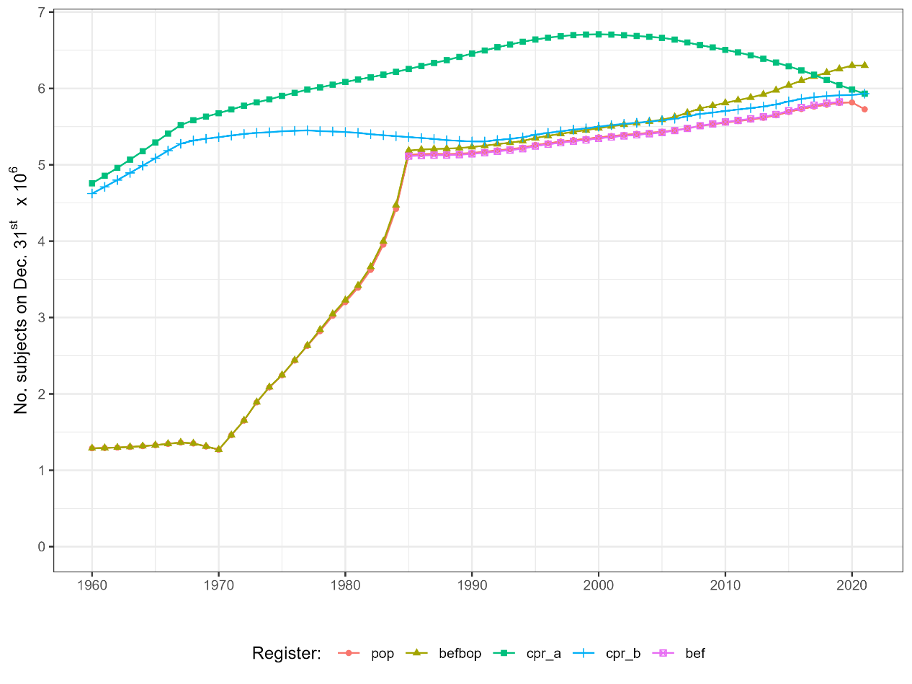

Note that POP and BEF are indistinguishable from 1985-2019 and POP and BEFBOP are indistinguishable from 1960-1984.
The next figure zooms in on the period 1985-2021. Observe that the vertical axis is cut at 5 million.

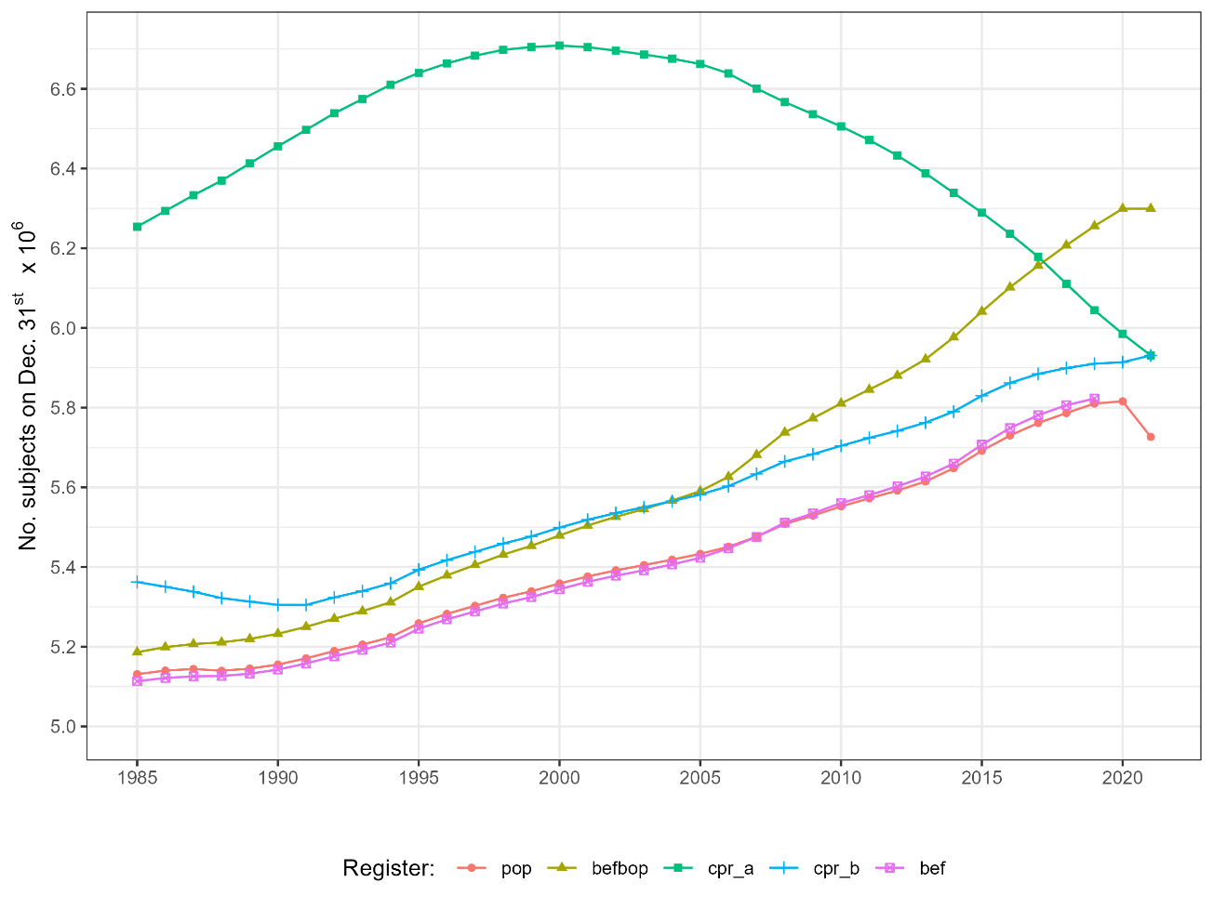

BEF is initiated in and available from 1985. Comparison with official numbers for the Danish population (see www.dst.dk) available on the first of January each year has shown almost perfect comparability with numbers in BEF (recorded on December 31st the year before) differing in most years by less than 100 subjects.
BEFBOP, also initiated in 1985, appears to include residency periods on some subjects prior to 1985 though rather sporadically. From 1985-2021 an increasing number of subjects are included, which, since they are not in BEF, must be subjects who are not resident in Denmark. (The derivation of POP shows that all subjects in BEF are also in BEFBOP, so the difference between BEF and BEFBOP amounts to an additional number of subjects in BEFBOP)
CPR_b was initiated in 1968 and presumably the subjects recorded in CPR 1960-1967 include subjects also available on the initiation in 1968 (for example subjects who died before 1968 will not be included in CPR). CPR appears to include more subjects than those who are alive and resident in DK (in comparison to BEF).
CPR_a is less relevant in this context because many subjects are included from their date of birth even though they have not yet immigrated to Denmark (start date often occurs much later than date of birth).
The following figure displays the number of subjects in each of the registers on the last day of each month during 2020 and 2021.
The curve for BEBPOP is seen to be flat after Oct. 2020 because no subjects enter or leave the register after the end of Oct. 2020. The curves for the CPR register are also almost flat between Nov. and Dec. 2021 because very little information is available for CPR in Dec. 2021. This results in POP decreasing from Oct. 2020, since no new subjects are included in the population from this time forward (more on this in the next section).
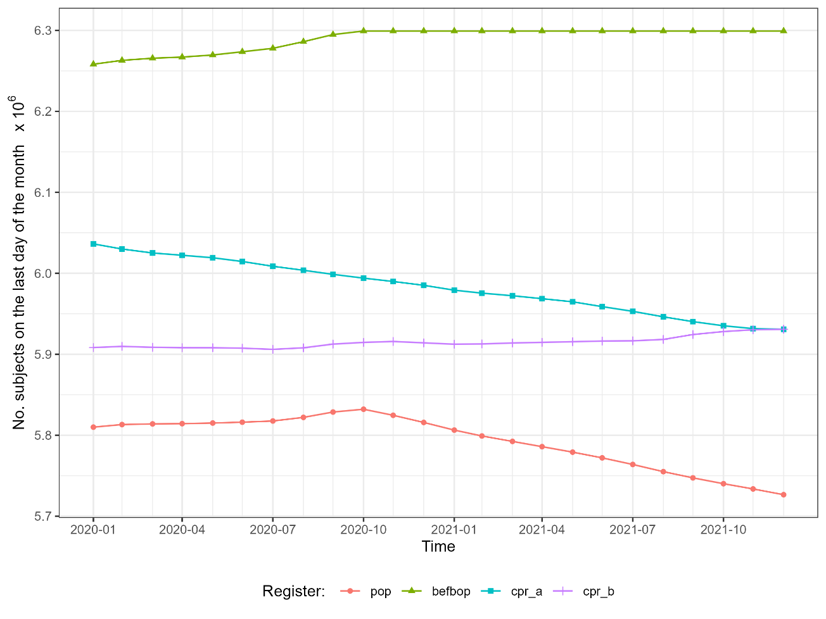

Characterization of POP
For 1960-1985 POP, because it is based on BEFBOP, is a very inaccurate representation of Denmark. For statistical analyses including this period, another population definition will have to be used. This population should be based on CPR_b and it will be relevant to include inclusion criteria in the analyses that ensure that subjects are alive and resident in Denmark because CPR_b will include observation periods for subjects who are not resident in Denmark.
For 1985-2019 POP is an accurate representation of subjects alive and resident in Denmark as verified by the comparison to BEF during 1985-2019. The population sizes may differ by a few thousand subjects and closer comparison of POP and BEF at 2019-12-31 shows that there are subjects in BEF not in POP as well as subjects in POP not in BEF. This is most likely the case throughout the period.
In 2021 we have used data for CPR at the last available date (2020-12-07). For BEFBOP we have used data from 2020-12-31 for both 2020 and 2021 in the graph (thus the flat curve for BEFBOP between 2020 and 2021).
From 2020-10-29 to 2021-12-31 the data in POP is only an approximation to the Danish population. Because POP is based on BEFBOP (ending 2020-10-29) no new people are being introduced into POP after 2020-10-29 (births in or emigration into Denmark) while subjects’ observation periods are still being censored due to death, emigration, and inactivation. This is seen in the second figure from the considerable drop in size of POP from 2020 to 2021 and also seen from the last figure showing that the population size peaks by the end of Oct. 2020.
In addition, subjects who no longer have a valid address at any point after 2020-10-29 but are not recorded as dead (from DOD), emigrated (from VNDS), or otherwise inactivated (from CPR until 2020-12-07) will not be censored while they should have been (and if BEFBOP had been available until 2021-12-31 they would have been censored when they were no longer recorded on a valid address).
Recommendations on which registers to use depending on study period is given in the following table.
Study period | Register to be used
Until 1984 | CPR_b + inclusion criteria (alive and resident in DK)
1985 to Oct. 2020 | POP
From Oct. 2020 | POP, with caution of non-satisfactory censoring after Oct. 2020

Appendix

Location of registers on DST project 708237
Register | Path to register on 708237
CPR (t_person) | Rawdata/708237/Eksterne data/t_person.rds
BEF | Rawdata/708237/Grunddata/befYYYY12.rds for YYYY=1985-2019
BEFBOP | Rawdata/708237/Grunddata/befbop202012.rds
VNDS | Rawdata/708237/Grunddata/vnds2021.rds
DOD | Rawdata/708237/Grunddata/dod2021.rds
POP | Workdata/708237/02_data_derived_2022b/02_population_full/analysis_data.rds

In addition, detailed documentation on POP is available from Workdata/708237/02_data_derived_2022b/reports/10_make_population.html

Links to more information on the registers
Further information on the DST registers and included variables (though not all are available on 708237) are available from https://www.dst.dk/extranet/forskningvariabellister/Oversigt%20over%20registre.html
Documentation on the CPR register is available from: https://sundhedsdatastyrelsen.dk/da/registre-og-services/om-de-nationale-sundhedsregistre/personoplysninger-og-sundhedsfaglig-beskaeftigelse/cpr-registeret
Variables, tables, codes etc. in CPR are documented here: https://sundhedsdatastyrelsen.dk/-/media/sds/filer/registre-og-services/nationale-sundhedsregistre/personoplysninger-og-sundhedsfaglig-beskaeftigelse/cpr-registeret/dokumentation-af-cpr.xls?la=da

Revision log
2022-10-13 (RHBC): Initial document
2022-10-20 (RHBC):
- Updated with better figures
- Monthly changes during 2020-2021 added.
2022-10-21 (CSG):
- Minor corrections

